The Chailey Levels of Ability
Assessment Charts

Assessment details

NAME

D.O.B.

DIAGNOSIS

DATE OF ASSESSMENT

ASSESSMENT CENTRE

NAME OF ASSESSOR

Notes

CHAILEY HERITAGE CLINICAL SERVICES Beggars Wood Road
North Chailey, East Sussex BN8 4JN

Tel: 01825 722112 Fax: 01825 724729 Web: www.southdowns.nhs.uk

ACTIVE DESIGN LTD

68K Wyrley Road, Witton, Birmingham B7 7BN

Tel: 0121 327 7506 Fax: 0121 327 8807 E-mail: enquiries@activedesign.co.uk Web: www.activedesign.co.uk

© Chailey Heritage Clinical Services 2004

Illustrations
Liz Roberts and Coral Mula

Graphic design
Jenny Searle Associates
How to use the

How to use the assessment charts
assessment ch rts

The analysis of the child’s movement is more important than ascribing a level.

To reach a level of ability all components of that level must be achieved.

There may be a difference between the level of ability a child can achieve when trying his best and his consistent level. The consistent level should be identified and recorded, ability at ‘best’ should be noted separately. A child who rests in an asymmetrical position
is at risk of developing deformity so his resting position also needs to be checked.

A child needs to achieve each component of a level before they can be said to have reached it. The charts will help provide a detailed analysis of areas which may be limiting a child’s progress, and where he is doing well.

The following items should be noted on the assessment chart: if the child was assessed in or out of any equipment, and what that equipment was; the type of surface used for the assessment e.g. mat or floor, ramped cushion, and if orthoses were worn.

These charts can be used to record a child’s ability in a number of situations. It is important to use each sheet only once. You can photocopy or print them out as you need them.

During the Assessment

• Encourage a child through movement and play to achieve his highest level of ability without assistance

• Observe a child, considering each of the sections on the side of the chart separately

• In each section, mark the items you observe a child achieving consistently by placing a tick in the box under the ‘Achieved’ heading

• Record any notes or specific observations in the assessment notes section

2

Scoring the Components Groups

• Score the level for each Component Group separately.

• Match the components achieved with the numbers and record the highest corresponding level of ability. All components indicated
by solid black numbers must be present to achieve a level of ability

• Some components, indicated by bracketed numbers, may be observed but are not essential when scoring a level of ability

• Occasionally, the components achieved may not correspond with those required for any level of ability. In this case, place a dash in the box

• Careful analysis of any Component Groups with a dash will be needed to determine the reason

Ascribing an overall Level of Ability

• Record the lowest Level of Ability observed for any Component Group

• This is a child’s Overall Level of Ability

Points for clarification

Below are some common mistakes and confusions which are made when assessing a child’s Chailey Level of Ability. These points may help you with your assessments:

• At higher levels of ability a range of movement, particularly at the pelvis, needs to be present for a child to achieve that level. For example, a child with an anteriorly tilted pelvis who cannot achieve a neutral or posterior tilt would not be able to achieve a Level 4 prone or supine.

• The details of symmetry, position and movement of the limbs are essential in determining the Chailey Level of Ability and identifying the risk of deformity. Functional skills are not sufficient evidence of a level of ability, e.g. independent sitting with posteriorly tilted pelvis does not represent a Level 3 sitting position.

The example shown opposite looks at an illustration of supine lying. It is not possible to make an accurate assessment of a child’s ability from a still picture. For the purposes of the example, not all of the sections have been shown. All sections should be completed when assessing the level of ability. The example shows part of an assessment chart that would result in the child achieving a Chailey Level of Ability 2 in supine.

3

Worked example

1 Observe each Component Group

2 Tick the box to record that you have observed the component and the child has achieved it

3 Record the level achieved of each Component Group

4 Record the LOWEST level achieved from all the Component Groups in the Overall Level of Ability box.

5 Record other details of the assessment including use of equipment, supporting surface and use of orthoses


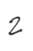

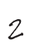

Below is an extract from a Supine Lying assessment chart.

COMPONENT COMPONENT GROUP
CHAILEY LEVEL OF ABILITY GROUP 1 2 3 4 5 6 SCORE

Shoulder Girdle Position
Pelvic Girdle Position

Leg Position
Retracted Neutral Protracted
Posteriorly tilted Neutral Anteriorly tilted
Asymmetrical position and movement Hips abducted and externally rotated Hips extended, knees straight
Hips and knees both flexed at 90o Feet touching midline
Hips flexed, knees straight
1 2 (3) (4) (5) (6) 3 4 5 6
4 5 6
1 2 (3) 4 5 6 3 4 5 6
4 5 6
1 2
3 4 5 6 4 5 6 4 5 6 4 (5) (6)
(5) (6)

IN EQUIPMENT OVERALL LEVEL OF ABILITY: OUT OF EQUIPMENT
TYPE OF SURFACE:

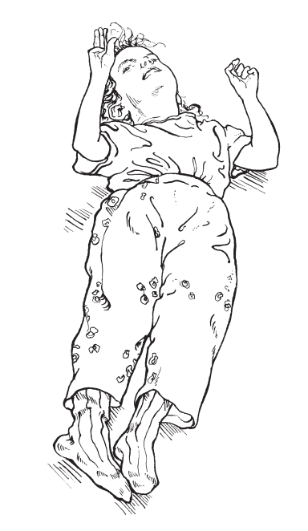
She is achieving Level 3 in her shoulder girdle position as it is in neutral. Her pelvis and leg position, however, are still at Level 2. She has two of the components required for Level 4 as her feet are touching in midline and her hips are extended with the knees straight. She does not have her hips abducted and externally rotated or hips and knees both flexed at 90°.

The dash on ‘Leg Position’ indicates she does not yet have the variety of movement required to achieve Level 3 or 4 (or it was not observed during the assessment).

4
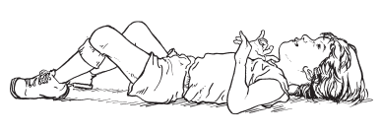
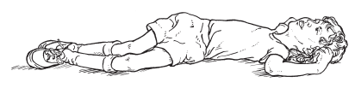
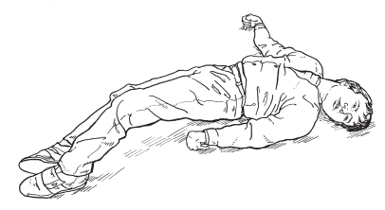
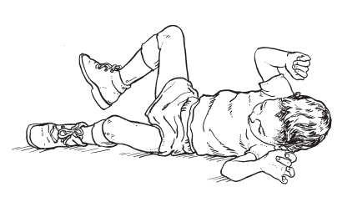
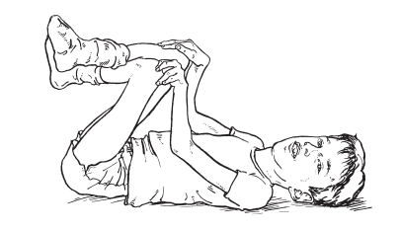

Chailey Levels of Supine Lying Ability

LEVEL 1
• Unable to maintain supine when placed except momentarily and very asymmetrically
• Settles into sidelying – body follows head turning in a total body movement
• Loadbearing through lateral aspect of head, trunk, upper arm and thigh
• Neck extended with chin poked
• Shoulder girdle retracted and pelvis posteriorly tilted
• Arm movement random

LEVEL 4
• Symmetrical posture
• Loadbearing through anteriorly tilted pelvis, protracted shoulder girdle and upper trunk
• Ability to change loadbearing to head and trunk only
• Able to retract chin and turn head freely • Definite lordotic curve
• Shoulders able to flex and adduct allowing midline hand play above chest
• Free pelvic movement beginning allowing child to touch knees with flexed hips or extend hips and knees
• Feet to midline
• Beginning of lateral load shift • Unilateral leg raise

Supine Lying assessment notes

COMPONENT GROUP
Symmetry
Loadbearing
Shoulder Girdle Position
Pelvic Girdle Position
Lateral Spinal Profile
Head Movement
Chin Position
Arm and Hand Position
Leg Position
Activities
LEVEL 2
• Asymmetrical posture
• Settles on back when placed
• Loadbearing through head, shoulder girdle, trunk and posteriorly tilted pelvis
• Chin poked
• Shoulder girdle retracted, shoulders externally rotated and abducted
• Arms to side
• Head to one side, pelvis and legs to opposite side
• Head movement followed by pelvic movement in the opposite direction
• Arm movement random

LEVEL 5
• Loadbearing on shoulder girdle and pelvis or only on centre of trunk
• Free movement of shoulder girdle and pelvis on trunk
• Able to retract chin
• Pelvis has full range of movement, infants able to play with toes with hips flexed and knees extended and roll into sidelying
• Can return to supine
• Hand and foot play crossing midline

NOTES AND OBSERVATIONS
LEVEL 3
• Maintains symmetrical posture
• Loadbearing through head, shoulder girdle, pelvis and feet
• Neutral pelvic tilt and shoulder girdle neutral giving general trunk curvature
• Hips abducted and externally rotated
• Chin tucked but not retracted and head able to turn freely from side to side
• Controlled eye movements possible
• Beginning of unilateral grasp to side of body, takes fist and objects to mouth

LEVEL 6
• As for level 5
• Pelvis and shoulder girdle moving freely • Consistent ability to roll into prone by
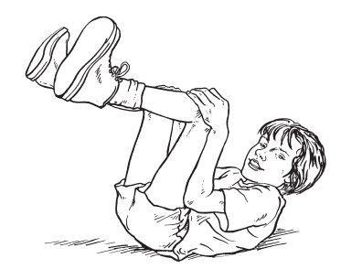
achieving sidelying as in level 5 and then anteriorly tilting pelvis on trunk and extending hips

5
Name Date

Supine Lying Assessment Chart

Record only the components you observe the child achieving consistently by placing a tick in the box. To assess the child’s level of ability, place him in supine on a firm but compliant surface.

COMPONENT GROUP COMPONENT CHAILEY LEVEL OF ABILITY GROUP 1 2 3 4 5 6 SCORE

Symmetry

Loadbearing

Shoulder Girdle Position

Pelvic Girdle Position

Lateral Spinal Profile

Head Movement

Chin Position

Arm and Hand Position

Leg Position

Activities
Unable to maintain symmetrical position Able to maintain symmetrical position
Able to move in and out of symmetry actively In sidelying (obligatory)
Head
Shoulder girdle Trunk
Pelvis Feet Retracted Neutral
Protracted Posteriorly tilted Neutral Anteriorly tilted Flat back
Long curve Lordotic
Trunk follows head movement
Head movement followed by
pelvic movement in opposite direction
Turns head freely Poked
Tucked Retracted Random
Out to side, away from body Unilateral grasp to side Takes hand to mouth
To midline
Playing with both hands above chest Cross midline
Asymmetrical position and movement Hips abducted and externally rotated Hips extended, knees straight
Hips and knees both flexed at 90o Feet touching midline
Hips flexed, knees straight Turns head to look Unilateral hand play
Able to touch knees with hands Able to touch feet with hands Able to roll into sidelying
Able to roll into prone
1 2
3 4 5 6 4 5 6
1
2 3 4 5 6 2 3 4 5 6 2 (3) 4 5 6 2 3 4 5 6 (2) (3) 4 (5) (6)
1 2 (3) (4) (5) (6) 3 4 5 6
4 5 6 1 2 (3) 4 5 6
3 4 5 6 4 5 6
1 2 (3) (4) (5) (6) 3 (4) (5) (6)
4 5 6 1 (2) (3) (4) (5) (6)

2 (3) (4) (5) (6) 3 4 5 6
1 2 (3) (4) (5) (6) 3 4 5 6
4 5 6 1
2 (3) (4) (5) (6) 3 (4) (5) (6) 3 (4) (5) (6)
4 5 6 4 5 6 5 6
1 2
3 4 5 6 4 5 6 4 5 6 4 (5) (6)
(5) (6) 2 (3) (4) (5) (6)
3 (4) (5) (6) 4 (5) (6)
5 6 5 6
6

OVERALL LEVEL OF ABILITY:

IN EQUIPMENT
OUT OF EQUIPMENT TYPE OF SURFACE:

6
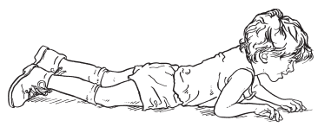
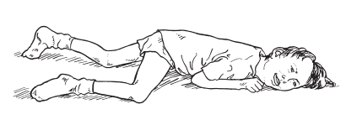
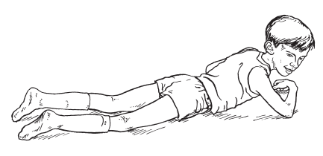
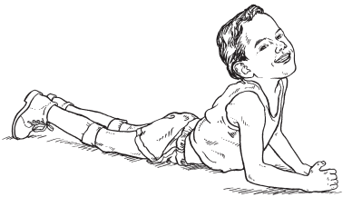

Chailey Levels of Prone Lying Ability

LEVEL 1
• Asymmetrical top-heavy posture
• Loadbearing through face, chest, shoulders, forearms and knees and feet
• Pelvis posteriorly tilted • Hips and knees flexed • Head to one side
• Chin poked
• Shoulder girdle retracted, shoulders flexed and adducted
• Flat back profile
• Mouthing hand is possible in this position

LEVEL 4
• Loadbearing through abdomen, thighs and feet, with either hand or forearm propping
• Pelvis anteriorly tilted but not anchoring • Shoulder girdle protracted
• Angular back profile of upper chest and lower back.
• Able to retract chin
• Free head movement
• Head and upper trunk movement can be dissociated from lower trunk allowing pivoting
• Hand and foot play in midline

Prone Lying assessment notes

COMPONENT GROUP
Symmetry
Loadbearing
Shoulder Girdle Position
Pelvic Girdle Position
Lateral Spinal Profile
Head Movement
Chin Position
Arm and Hand Position
Leg Position
Activities
LEVEL 2
• Asymmetrical posture • Settles when placed
• More generalised loadbearing through face, chest, upper abdomen, forearms knees and feet
• Pelvis posteriorly tilted
• Shoulder girdle retracted
• Shoulders flexed and adducted with elbows resting behind shoulders
• Hand and arms to side, hips and knees slightly flexed
• Head to one side • Chin poked
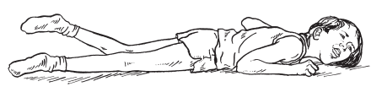
• Beginning to lift head from floor with flat back profile and associated lateral pelvic movement

LEVEL 5
• Loadbearing through iliac crests, thighs and lower abdomen with hand propping on extended elbows
• Pelvis anteriorly, neutral or posteriorly tilted • Shoulder girdle protracted
• Angular profile between pelvis and lower back and upper trunk and head
• Able to retract chin
• Free head movement
• Pelvic anchoring enabling efficient pivoting and backward movement
• Able to roll into supine

NOTES AND OBSERVATIONS
LEVEL 3
• Symmetrical posture
• Load bearing through lower chest, abdomen, thigh, knees and forearms
• Pelvis and shoulder girdle in neutral • Props on forearms
• Long curve back profile • Head in line with spine • Chin tucked
• Uncontrolled lateral load shift so may topple into supine

LEVEL 6
• Free movement of pelvis and shoulder girdle
• Beginning to load bear on hands and knees
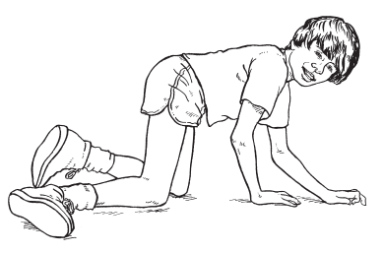
• Rocking backwards and forwards in this position

7
Name Date

Prone Lying Assessment Chart

Record only the components you observe the child achieving consistently by placing a tick in the box. To assess the child’s level of ability, place him in supine on a firm but compliant surface.

COMPONENT GROUP COMPONENT CHAILEY LEVEL OF ABILITY GROUP 1 2 3 4 5 6 SCORE

Symmetry

Loadbearing

Shoulder Girdle Position

Pelvic
Girdle Position

Lateral Spinal Profile

Head Movement

Chin Position

Arm and Hand Position

Leg Position

Activities
Unable to maintain symmetrical position Able to maintain symmetrical position
Able to move in and out of symmetry actively Face
Shoulders Chest Abdomen
Forearm and hand Hands, elbows extended Pelvis
Thighs Knees Retracted Neutral Protracted
Posteriorly tilted Neutral Anteriorly tilted
Anteriorly tilted and anchoring Flat back
Long curve Lordotic
Unable to move
Difficulty turning head side to side Able to turn side to side
Moves head freely Poked
Tucked Retracted
Tucked under chest To side
Elbows behind shoulders Propping on forearms
Propping on hands, elbows flexed Propping on hands, elbows extended Able to release for one hand play Asymmetrical position and movement Symmetrical midline leg position
Four point kneeling Lifts head with flat back
Lifts head with curved back Able to pivot to left and right Able to move backwards Able to roll into supine
Able to attain all fours
1 2
3 4 5 6 4 5 6
1 2 (3) (4) (5) (6) 1 2 (3) (4) (5) (6) 1 2 3 (4) (5) (6) 2 3 4 5 (6)
1 2 3 4 (5) (6) 5 6 5 (6)
2 3 4 5 (6) 1 2 3 4 5 6 1 2 (3) (4) (5) (6)
3 (4) (5) (6) 4 5 6
1 2 (3) (4) (5) 6 3 (4) (5) 6
4 5 6 5 (6)
1 2 (3) (4) (5) (6) 3 (4) (5) (6)
4 5 6 1
2
3 (4) (5) (6) 4 5 6
1 2 (3) (4) (5) (6) 3 4 5 6
4 5 6 1
2 (3) (4) (5) (6) 2 (3) (4) (5) (6) 3 (4) (5) (6)
4 (5) (6) 5 6 5 6
1 2
3 4 5 6 6
2
3 4 (5) (6) 5 (6) 5 6 5 6
6

OVERALL LEVEL OF ABILITY:

IN EQUIPMENT
OUT OF EQUIPMENT TYPE OF SURFACE:

8
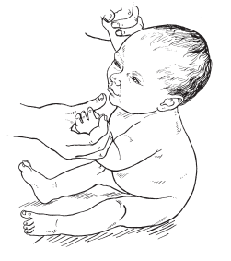
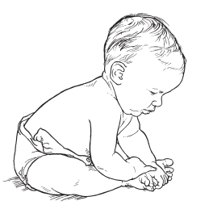

Chailey Levels of Floor Sitting Ability

LEVEL 1
• Originally described during work with children who had cerebral palsy
• Not observed in our study of normal infants
• Cannot be placed in a sitting position
• Trunk weight cannot be brought forwards over his sitting base
• This may be for a variety of reasons, including a strong tendency to extend, extreme floppiness or fixed deformities

LEVEL 5 • As Level 4
• Able to tilt the pelvis anteriorly and posteriorly enabling balance with the trunk behind the base
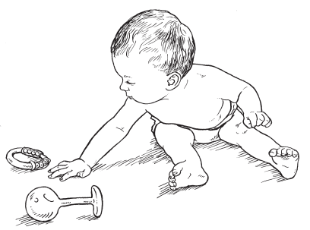
• This allows unilateral leg movement
• Can reach fo out of his ba
• Can recover after leanin either side
LEVEL 2
• Can be placed in a sitting position
• Needs holding to stay in position
• Trunk weight can be brought forward over his sitting base.
• Pelvis is posteriorly tilted • Hips are abducted and
externally rotated
• Loadbearing through the buttocks and lateral aspect of the feet
• Shoulder girdle is retracted or in neutral
• The back profile is rounded

• Hips are predominantly neutral • Loadbearing through the
buttocks and back of thighs • Arms can move above
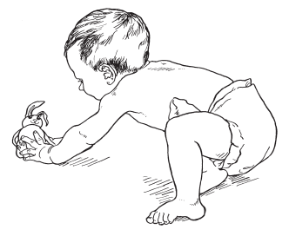
shoulder height
LEVEL 3
• Can be placed in a symmetrical sitting position
• Can maintain this as long as he does not move
• Pelvis is in neutral tilt
• Hips abducted and externally rotated
• Loadbearing through the buttocks and lateral aspect of the legs and feet
• Chin is tucked
• Shoulder girdle is protracted • Hands propping or otherwise
aiding balance
• Weight is forward over the sitting base

LEVEL 6 • As Level 5
• Can move from the sitting position forward into prone
• This is by ‘off loading’ a buttock and leaning forward and sideways in a controlled way
LEVEL 4
• Can be placed in a symmetrical sitting position
• Able to move his trunk forward within his base
• Able to return to upright
• Able to move laterally within base
• Able to rotate trunk within base • Pelvis is anteriorly tilted
• Hips mainly abducted and externally rotated but can move to a more neutral position
• Can retract chin
• Shoulder girdle is protracted • Arms can move to shoulder
height
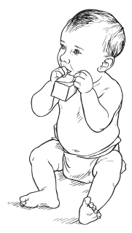
• The back profile is upright • Hands can be
brought to midline

LEVEL 7 • As Level 6
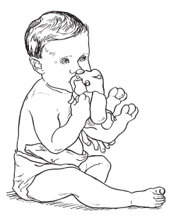
• Child can regain sitting position from prone

Floor Sitting assessment notes

COMPONENT GROUP NOTES AND OBSERVATIONS
Ability to be positioned
Loadbearing
Shoulder Girdle Position
Pelvic Girdle Position
Spinal Profile
Chin Position
Trunk Position and Movement
Hip Position
Activities

9
Name Date

Floor Sitting Assessment Chart

Record only the components you observe the child achieving consistently by placing a tick in the box. To assess the child’s level of ability, place him on the floor in either long or cross-legged sitting.

COMPONENT GROUP COMPONENT CHAILEY LEVEL OF ABILITY GROUP 1 2 3 4 5 6 7 SCORE

Ability to be positioned

Loadbearing

Shoulder Girdle Position

Pelvic Girdle Position

Spinal Profile

Chin Position

Trunk Position and Movement

Hip Position
Activities
Cannot be placed
Placeable but not able to maintain position Able to maintain position but not move
Able to maintain position and move within base Able to maintain position and move outside base Able to move out of position
Able to attain position Buttocks
Feet
Lateral aspect of legs Retracted
Neutral Protracted
Posteriorly tilted (uncontrolled) Neutral
Anteriorly tilted
Posteriorly tilted (controlled) Rounded
Upright Poked Tucked Retracted Behind base
Forward over base Rotate trunk within base
Forwards and laterally within base Forwards and laterally outside base Recovers balance from behind base Abduction and external rotation Variable, uncontrolled, none Propping to balance
Able to raise to shoulder height Able to bring hands into midline
Able to raise above shoulder height
1
2
3
4
5
6
7 2 3 4 5 6 7 2 3 4 5 6 7 2 3 4 5 6 7
1 2 (3) (4) (5) (6) (7) 3 (4) (5) (6) (7) 3 4 5 6 7
1 2 (3)
3 (4) 5 6 7 4 5 6 7
(4) 5 6 7 2 3 (4) (5) (6) (7)
4 5 6 7 1 2 (3) (4) (5) (6) (7)
3 4 5 6 7 4 5 6 7
1
2 3 4 (5) (6) (7) 4 (5) (6) (7) 4 (5) (6) (7)
5 6 7 5 6 7
2 3 4 5 6 7 1 2
3 (4) (5) (6) (7) 4 (5) (6) (7) 4 5 6 7
5 6 7

OVERALL LEVEL OF ABILITY:

IN EQUIPMENT
OUT OF EQUIPMENT TYPE OF SURFACE:

10
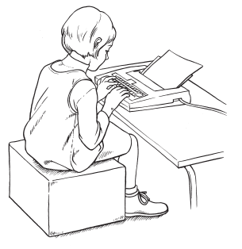

Chailey Levels of Box Sitting Ability

LEVEL 1
• Originally described during work with children who had cerebral palsy
• Not observed in the study of normal infants
• Child cannot be placed in the sitting position
• Trunk weight cannot be brought forwards over sitting base
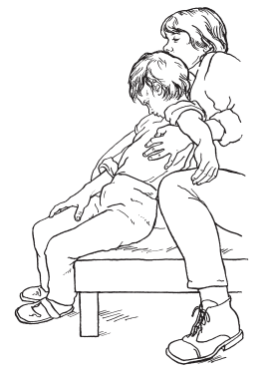
• This may be for a variety of reasons including a strong tendency to extend, extreme floppiness or fixed deformities
LEVEL 2
• Can be placed in a sitting position
• Needs holding to stay in position
• Trunk weight can be brought forward over his sitting base
• Pelvis is posteriorly tilted
• Shoulder girdle is retracted or in neutral
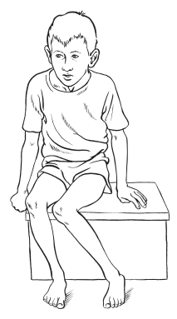
• The back profile is rounded
LEVEL 3
• Can be placed in a symmetrical sitting position
• Can maintain it as long as he does not move
• Pelvis is in neutral tilt • Chin is tucked
• Shoulder girdle is protracted • Hands propping or otherwise
aiding balance
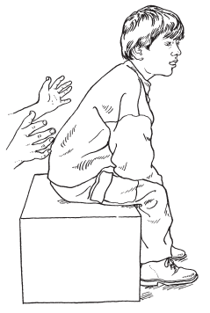
• Weight is forward over the sitting base
LEVEL 4
• Can be placed in a symmetrical sitting position
• Able to move trunk forward within base
• Able to return to upright
• Able to move laterally within base both ways
• Able to rotate trunk within base • Pelvis is anteriorly tilted
• Can retract chin
• Shoulder girdle is protracted • Arms can move to shoulder
height
• The back profile is upright. • Hands can be brought to
midline

LEVEL 5 • As Level 4
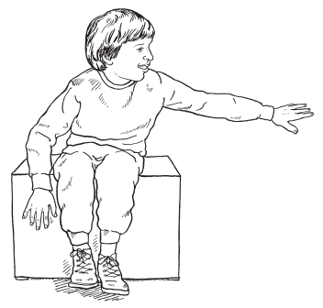
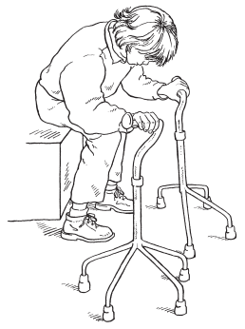
• Able to tilt the pelvis anteriorly and posteriorly enabling the trunk weight to fall behind
the base
• This allows unilateral leg movement
• Arms can move above shoulder height
• Can use hands freely • Can recover balance
after leaning to either side

Box Sitting assessment notes

COMPONENT GROUP
Ability to be Positioned
Loadbearing
Shoulder Girdle Position
Pelvic Girdle Position
Spinal Profile
Head Movement
Chin Position
Trunk Position and Movement
Hip Position
Activities
LEVEL 6
• As for Level 5
• Can sit independently
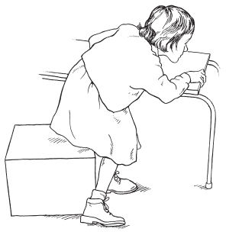
• Can transfer weight outside of sitting base to leave the position

NOTES AND OBSERVATIONS
LEVEL 7
• As for Level 6
• Can move into the sitting position

11
Name Date

Box Sitting Assessment Chart

Record only the components you observe the child achieving consistently by placing a tick in the box. To assess the child’s level of ability, place him in sitting on a flat box, ideally with the femora supported, hips in a neutral position, knees flexed at 90o, and feet flat on the floor spaced apart at the width of the pelvis.

COMPONENT GROUP COMPONENT CHAILEY LEVEL OF ABILITY GROUP 1 2 3 4 5 6 7 SCORE

Ability to be positioned

Loadbearing

Shoulder Girdle Position

Pelvic Girdle Position

Spinal Profile

Chin Position

Trunk Position and Movement

Hip Position

Activities
Cannot be placed
Placeable but not able to maintain position Able to maintain position but not move
Able to maintain position and move within base Able to maintain position and move outside base Able to move out of position
Able to attain position Buttocks
Feet
Posterior aspect of legs Retracted
Neutral Protracted
Posteriorly tilted (uncontrolled) Neutral
Anteriorly tilted
Posteriorly tilted (controlled) Rounded
Upright Poked Tucked Retracted Behind base
Forward over base Rotate trunk within base
Forwards and laterally within base Forwards and laterally outside base Recovers balance from behind base Neutral ab/adduction
Neutral int/external rotation Variable, uncontrolled, none Propping to balance
Able to raise to shoulder height Able to bring hands into midline
Able to raise above shoulder height
1
2
3
4
5
6
7 2 3 4 5 6 7 2 3 4 5 6 7
3 4 5 6 7 1 2 (3) (4) (5) (6) (7)
2 3 (4) (5) (6) (7) 4 5 6 7
1 2 (3)
3 (4) 5 6 7 4 5 6 7
(4) 5 6 7 2 3 (4) (5) (6) (7)
4 5 6 7 1 2 (3) (4) (5) (6) (7)
3 4 5 6 7 4 5 6 7
1
2 3 4 (5) (6) (7) 4 (5) (6) (7) 4 (5) (6) (7)
5 6 7 5 6 7
4 5 6 7 4 5 6 7
1 2
3 (4) (5) (6) (7) 4 (5) (6) (7) 4 5 6 7
5 6 7

OVERALL LEVEL OF ABILITY:

IN EQUIPMENT
OUT OF EQUIPMENT TYPE OF SURFACE:

12
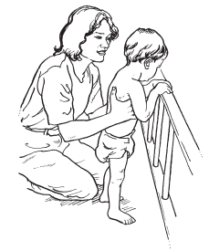
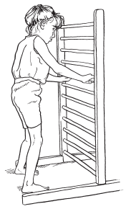

Chailey Levels of Standing Ability

LEVEL 1
• Unable to achieve or maintain position independently
• Needs to be fully supported under axillae
• Minimal loadbearing through side or forefoot
• Stepping reflex may be elicited • Unable to maintain head
upright
• Shoulder retracted
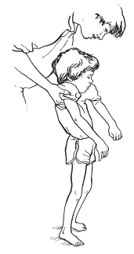
• Pelvis posteriorly tilted

LEVEL 5
• Able to achieve standing using support usually through half kneeling
• Able to move outside of base
• Loadbearing through hands and plantargrade feet
• Trunk upright
• Able to lean backwards and rotate whole trunk
• Free pelvic movement and lumbar lordosis
• Can reach above shoulder height
• Stepping within position
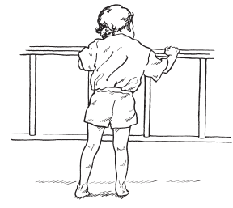
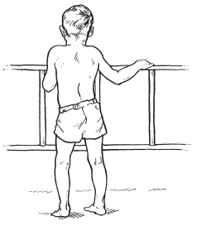
• Leaves position in controlled way using support
LEVEL 2
• Unable to achieve or maintain position independently
• Needs to be held under axillae or held onto support
• Using support, loadbearing through trunk, forearms, hands and toes or plantargrade feet
• Standing base smaller than or as wide as pelvis
• Able to maintain head upright • Pelvis posteriorly tilted
• Shoulder girdle protracted
• May bend and straighten knees

LEVEL 6
• Moving freely into and out of position using support
• Cruising initially using three points of support with broad standing base
• Progressing to two points with narrow base
• Free pelvic movement and lumbar lordosis
• Loadbearing through plantargrade feet, occasionally tiptoes
• Decreasing amount of hand support, which is mainly used for balance
LEVEL 3
• When placed at support is able to maintain standing
• Not able to move
• Loadbearing through trunk, forearms or hands and plantargrade feet
• Standing base width of pelvis • Pelvis in neutral tilt
• Shoulder girdle protacted
• Uncontrolled load shift and leg movement
• Flat back profile

LEVEL 7
• Able to stand independently by releasing hands from support for a few seconds
• Able to leave position without support
• Standing base as wide or slightly wider than pelvis
• Arms in medium to high guard position
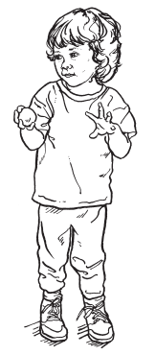
• Toe grasping
LEVEL 4
• When placed at support able to maintain position
• Able to move within base
• Loadbearing through hands and plantargrade feet
• Trunk upright and able to move away from support
• Standing base as wide or wider than pelvis
• Pelvis anteriorly tilted
• Shoulder girdle protracted • Can free one hand for play
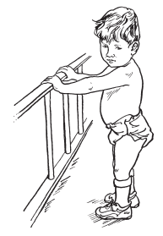
• Single leg movements may occur

LEVEL 8
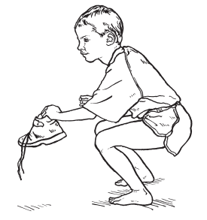
• Assumes standing independently from quadruped or squatting position using hands

Standing Ability assessment notes

COMPONENT GROUP NOTES AND OBSERVATIONS
Ability to be positioned
Loadbearing
Loadshifts
Shoulder Girdle Position
Pelvic Girdle Position
Head position
Arm and hand position
Width of standing base

13
Name Date

Standing Assessment Chart

Record only the components you observe the child achieving consistently by placing a tick in the box. To assess the child’s level of standing ability, place the child in a standing position against a support at elbow height unless they require full support under axillae or can achieve standing independently.

COMPONENT GROUP COMPONENT CHAILEY LEVEL OF ABILITY GROUP 1 2 3 4 5 6 7 8 SCORE

Ability to be Positioned

Loadbearing

Loadshifts

Shoulder Girdle Position

Pelvic Girdle Position

Head Position

Arm and Hand Position

Width of Standing Base
Fully held under axillae, unable to maintain head upright
Fully held under axillae, able to maintain head upright
Needs to be held onto support Holds on to support if placed Holds support with one hand
Able to achieve standing position using a support Stands alone
Assumes standing independently Minimal or through side or forefoot Trunk on to support
Forearms on to support Hands on to support Tip toes
Plantargrade feet No load shift Uncontrolled
Able to move within base Steps within base
Able to move outside base
Able to leave position in controlled way Able to attain position
Able to cruise Retracted Neutral Protracted Posteriorly tilted Neutral Anteriorly tilted
Free pelvic movement Unable to maintain upright Able to maintain upright
Unable to release hands for play One hand free for play
Reaches above shoulder height Narrower than pelvis
Same as pelvis
Wider than pelvis

1

2 2
3
4 5
6
7
8 1
2 3 2 3
(2) 3 4 5 6 (2) (3) (4) (5) (6)
2 3 4 5 6 7 8 1 2
3
4 (5) (6) (7) (8) 5 (6) (7) (8) 5 (6) (7) (8) 5 6 7 8 5 6 7 8
6 7 8 1
(2) (3) (4) (5) (6) (7) (8) 2 3 4 5 6 7 8
1 2 (3) (4) (5) (6) (7) (8) 3 (4) (5) (6) (7) (8)
4 (5) (6) (7) (8) 5 6 7 8
1
2 3 4 5 6 7 8 1 2 3
4 5 6 7 8 5 6 (7) 8
1 2 (3) (4) (5) (6) (7) (8) 2 3 4 5 6 7 8
4 5 6 7 8

OVERALL LEVEL OF ABILITY:

IN EQUIPMENT
OUT OF EQUIPMENT TYPE OF SURFACE:

14

